**Assignment 3: Perform Parsing of Family Tree Using Knowledge Base**

**Problem Statement**

The goal of this assignment is to parse a family tree using a knowledge base and infer relationships such as parent, sibling, or cousin. By applying logical reasoning, you will deduce various familial connections.

**Objectives:**

* Parse a family tree using a knowledge base.
* Infer relationships such as parent, sibling, cousin, etc., using logical reasoning.
* Deduce various familial connections through the application of rules and facts.

**Theory:**

A family tree can be represented in a knowledge base using logical statements. These statements describe relationships such as "parent," "child," and "sibling." Using logical reasoning (often rule-based), new relationships, like "cousin" or "grandparent," can be inferred from the given facts.

**Methodology:**

1. Representation of Facts: Use facts such as parent(X, Y) (X is a parent of Y), sibling(X, Y) (X is a sibling of Y) in a knowledge base.
2. Rules for Reasoning: Define rules like grandparent(X, Z) (X is a grandparent of Z if X is a parent of Y and Y is a parent of Z) and use these rules to infer more complex relationships.
3. Parsing the Family Tree: Traverse the family tree using these rules to identify the desired relationships (e.g., cousins, aunts, and uncles).
4. Inference Engine: Implement an inference engine that can apply the defined rules to the facts and deduce relationships.

**Working Principle / Algorithm:**

1. Input: Provide the basic facts of the family tree (e.g., parent relationships).
2. Define Rules: Specify rules for inferring relationships (e.g., cousin, sibling, grandparent).
3. Reasoning: Apply the rules to deduce new relationships using logical inference.
4. Output: Display all inferred relationships (e.g., who is a cousin to whom).

**Advantages:**

* Allows for the automatic deduction of complex relationships from simple facts.
* Scalable to larger family trees and more complex familial connections.

**Disadvantages / Limitations:**

* The knowledge base needs to be carefully constructed with accurate facts and consistent rules.
* As the tree grows, inference can become computationally expensive.
* Some relationships (e.g., half-sibling) may require additional rules and complexity.

**Diagram :**

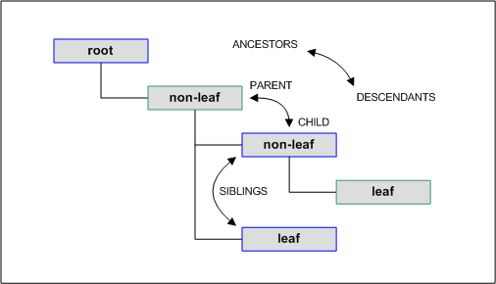

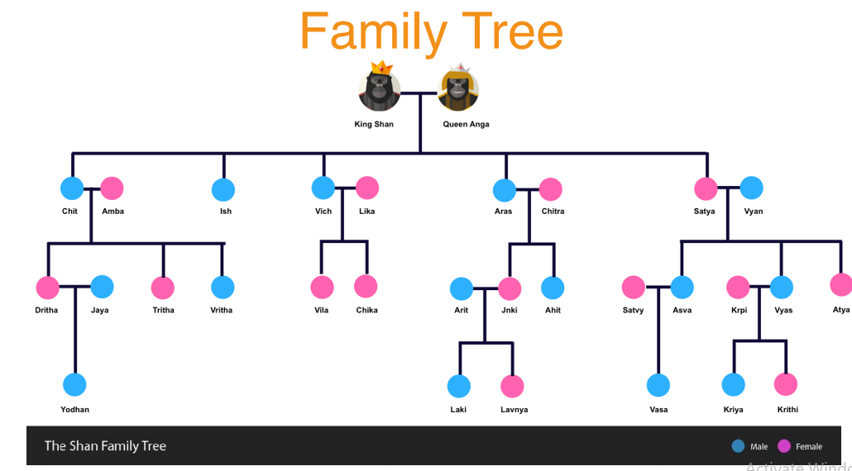

**Conclusion**

Using a knowledge base combined with inference rules provides a structured and effective way to parse and deduce relationships within a family tree. This approach enhances our ability to reason about familial connections, enabling a clearer understanding of the family structure.